Product Key Reader
Installation Instructions
Written by Leading Edge Stock Market Solutions, LLC
Copyright ©2013 Leading Edge Stock Market Solutions, LLC All Rights Reserved

- Go to http://www.maftrader.com/software.htm webpage and click the Download Key Reader link to download the Key Reader program.

- After the download is completed the Key Reader compressed (zipped) folder from the maftrader.com/ software page will be found in your Downloads folder as shown in Figure 1.
Open the Downloads folder on your computer.
Figure 1

- Right click the Key Reader zip folder.
Figure 2
- Select Extract All
Figure 3
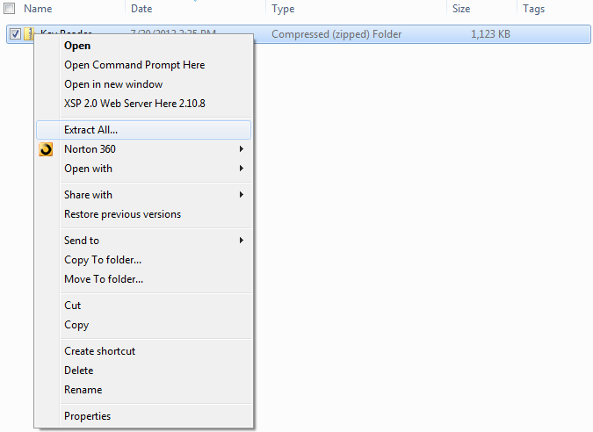

- The following window will be displayed, click Extract
Figure 4
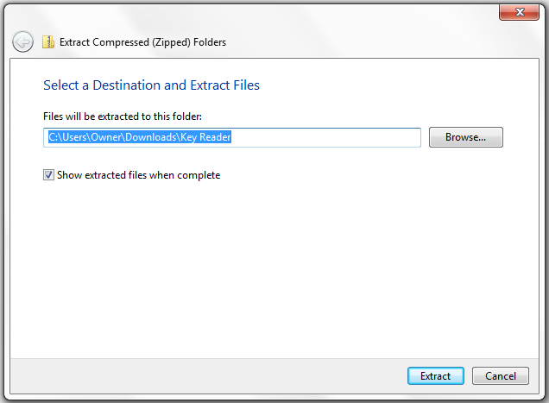

- After the Key Reader zip folder is extracted the extracted Key Reader folder will be displayed as shown in Figure 5. Double left click the Key Reader folder.

- Under the Downloads folder left click the Key Reader folder
Figure 5
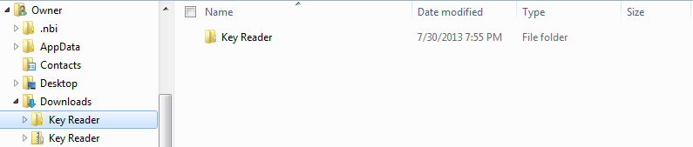
- A second Key reader folder will be displayed. Left click the second Key Reader folder to display the 3 files shown below.
- dotNetFx40_Full_setup
- Key Reader
- Setup
Figure 6
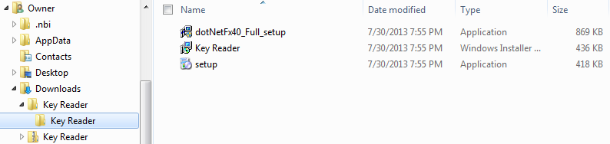

Microsoft .NET Runtime Environment Installation Procedure
- The Microsoft .NET runtime Installation Procedure installs the following application files on your computer:
Figure 7

- Double click the dotNetFx40_Full_setup file to install the .Net Framework 4.0 runtime environment support files. Follow the installation instructions.
Figure 8
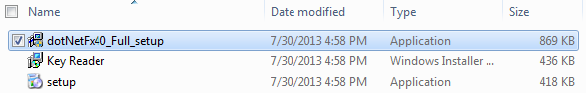

- The following setup window will be displayed. Select I have read and accept the license terms. Then click the Install button.
Figure 9
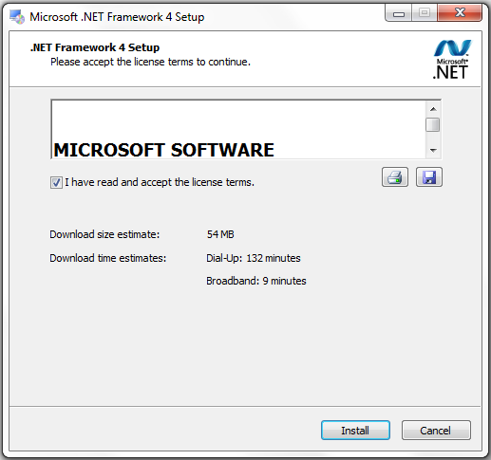

- After the Install button is clicked the software installation progress window will be displayed showing the progress of the .NET Framework 4 Client Profile software installation.

Figure 10
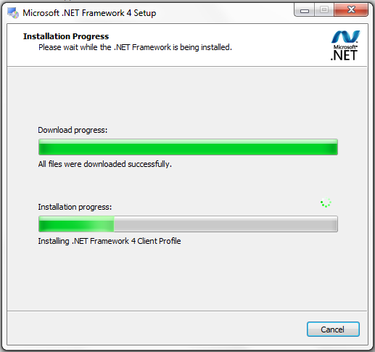

- After several minutes the Installation progress of the .NET Framework 4 Extended software application will be displayed.
Figure 11
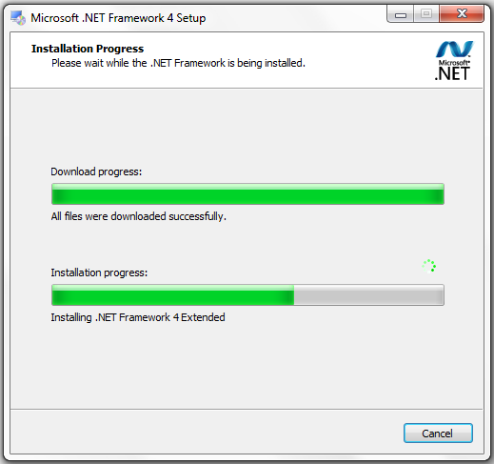
- When the installation has been completed the Installation Is Complete window will be displayed.
Click the Finish button
Figure 12
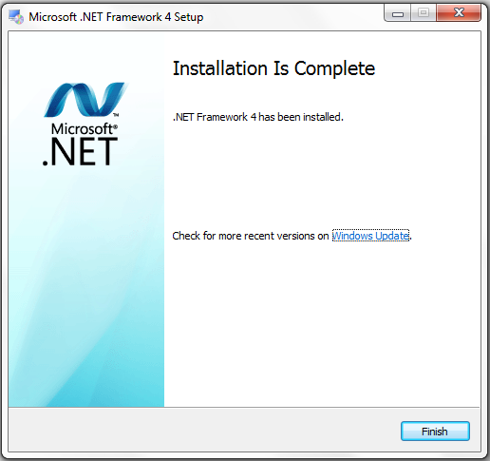

- After the dotNetFx40_Full_setup installation has been completed restart your computer.

Continue to the Key Reader Installation on the next page

Key Reader Installation

- After your computer has completed the restart, navigate to the Key Reader folder and click on it as shown in Figure 12. The files shown in Figure 7 will be displayed.
Under the Downloads folder left click the Key Reader folder

Figure 13

- A second Key reader folder will be displayed. Left click the second Key Reader folder to display the 3 files shown below.
- dotNetFx40_Full_setup
- Key Reader
- Setup

Figure 14

- Double click the setup file to open it.
Figure 15
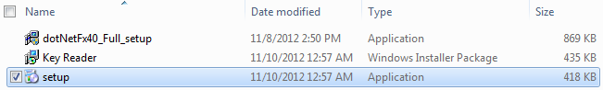

- The setup Wizard window will be displayed after a few seconds.

Figure 16
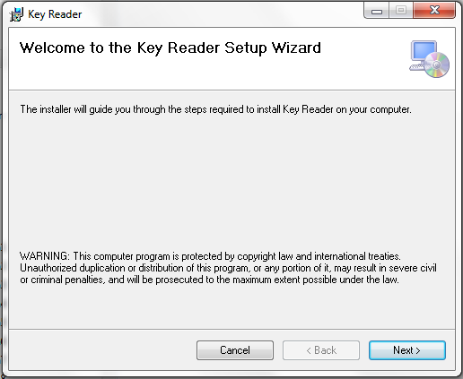
- Click Next
Figure 17
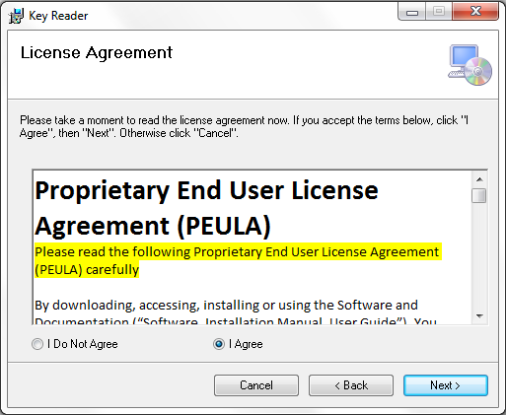
- Click I Agree, then click Next
Figure 18
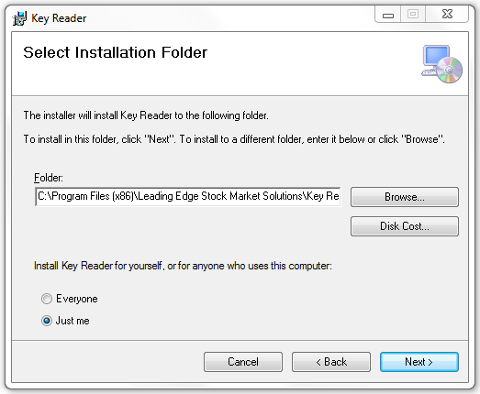
- Click Next

Figure 19
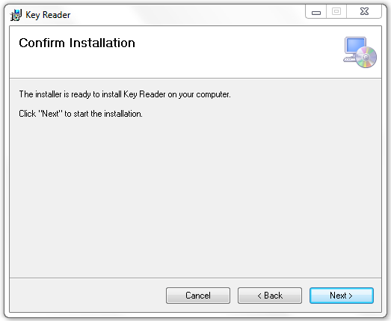
- Click Next
Figure 20
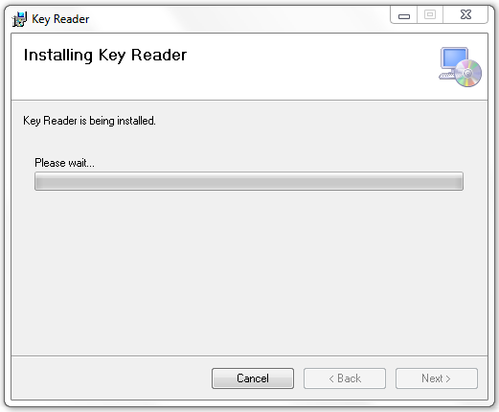

Figure 21
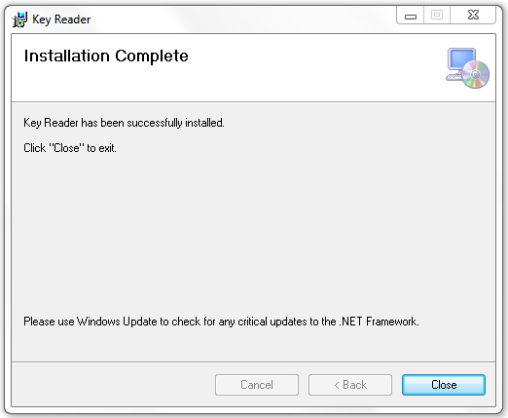
- Click Close
- After the setup installation has been completed restart your computer.

- Navigate to the location where the application was installed and double click on the icon to start the application as shown in Figure 22.
C:\Program Files(x86)\Leading Edge Stock Market Solutions\Key Reader

Figure 22

- A desktop shortcut can be created for the Key Reader program by performing a right mouse click on the Key Reader Application file and selecting Create Shortcut as shown in Figure 23 and Figure 24.
Figure 23
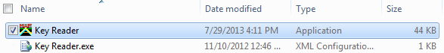

Figure 24
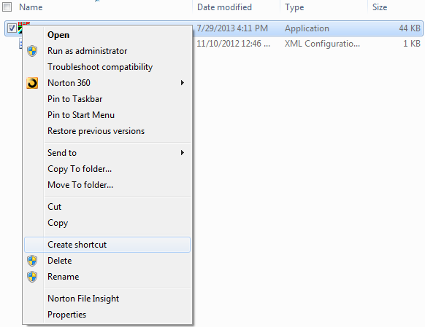

- Select the Desktop as the target for the shortcut
- The following Key Reader icon should now be displayed on your desktop.
Figure 25
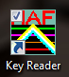

- Double left click the Key Reader icon. The following program window should open on your desktop:
Figure 26
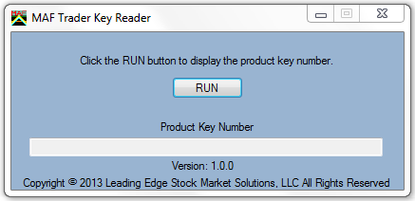

- Click the RUN button
- After a few seconds a unique Product key Number for your computer will be displayed in the Product Key Number textbox as shown below.
Figure 27
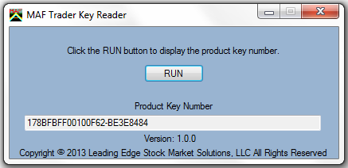

- Copy all the text in the Product Key Number textbox displayed in the Key Reader application running on your desktop.

Figure 28
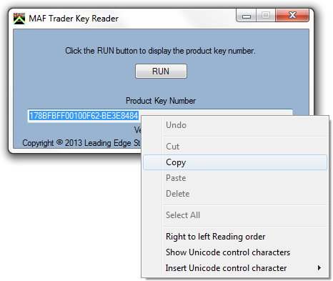

- Paste the Product Key Number into the order form in the Product Key Number input box at the MAFTrader.com website at the following url: https://www.maftrader.com/orderpage1.htm

- Complete the Product Order Form at Maftrader.com and click the submit button located at the bottom of the order form.

